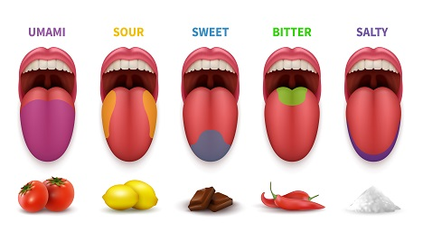
The Five Tastes
Taste is the sensation produced when a substance in the mouth reacts chemically with taste receptor cells. The tongue has around 60 million receptor cells.

Sweet
Something is “sweet” if it contains sugar. Sweetness is often described as the “pleasure taste”. Sugar is a source of energy and so it is desirable to the human body. Sweet complements well with the other basic tastes.
Salty
Salt is an important mineral for the human body and is necessary in our diets. It also enhances the flavor of food. Saltiness is detected by the taste buds through the presence of alkali metals. The more salt that you consume, the more the body wants – it’s addictive. Salt can also be used to amplify sweetness, for example in dark chocolate.
Sour
Sourness is a taste that detects acidity. It is when our tongues identify hydrogen ions (usually found in organic foods). This occurs when we consume dark green vegetables or citrus fruits such as oranges or lemons. A sour taste can also be obtained from fermented foods such as sauerkraut and yogurt. A little sourness is sometimes used on salad - vinegar or lemon juice.
Bitter
Bitter is the most sensitive of the five tastes. A large number of bitter compounds are known to be toxic, which is why many of us perceive bitterness to be unpleasant. However, a little bitterness can add great flavor - think about coffee, or beer! Antioxidants, which assist metabolism, account for the bitter taste in dark chocolate and coffee.
Umami
“Umami” is a Japanese word for “good flavor” and it is produced when you cook some amino acids. When you eat cheese, soy sauce, tomatoes, or cured meats, for example, you can identify the “umami” taste. Umami is sometimes described as “savory” or “meaty”. It is the most recently identified of the basic tastes. In the early part of the 20th century, a Japanese chemist named Kikunae Ikeda attempted to identify this taste common to asparagus, tomatoes, cheese and meat. But none of the four well-known tastes could describe it adequately. What he identified was the presence of “glutamic acid”, which he called “umami”. Western countries only accepted it as a “basic taste” in 1985.

Other words which can describe tastes:
- Spicy/Hot - Having strong flavors from spices or pepper
- Savory - Not sweet (bread, pizza, crackers, etc.)
- Acrid - Very sour/acidic
- Smoky - Tastes of smoke
- Rancid - A strong or unpleasant taste because it is not fresh
- Tasteless/Bland - No taste (boring!)
- Tasty – Delicious!

Textures. Texture is the way a food “feels” when you touch it or eat it.

Creamy
Creamy foods are smooth, soft and thick. They are often made with milk or cream. Avocados, ice cream, cream cheese and yogurt are all creamy foods.

Crumbly
“Crumbly” describes food that breaks into small pieces when you eat or touch it. For example: cookies are crumbly.

Crunchy
Crunchy foods are hard and make a noise when you eat them. For example, potato chips, nuts and raw carrots.

Greasy
Greasy foods taste of oil, and usually leave oil on your plate. Fried foods, such as sausages and burgers are greasy foods.

Gooey
“Gooey” describes foods that are viscous and sticky. Example: sweet sauces for ice-cream.

Moist/Dry
Moist foods are humid and soft. Dry foods are the opposite. Cakes can be moist or dry.

Mushy
Mushy foods are very moist. For example, potato purée.

Exercise. Which adjective(s) would you use to describe these foods?

White chocolate __________________________
Tapioca __________________________
Fried chicken __________________________
Honey __________________________
Milk, four weeks old __________________________
Large green pepper __________________________
Jalapeño pepper __________________________
Fried egg __________________________
Anchovies __________________________
Baked potato __________________________
Lettuce __________________________

